Optimizing User, Group, and Role Management with Access Control and Workflows

**Team Id: NM2025TMID19227**

**Team Members:**

* **Team Leader: M. Shanmuga Priya**
* **Team Member 1: M. Nandhini**
* **Team Member 2: A. Hari Priya**
* **Team Member 3: M. Vaishnavi**

**Problem Statement:**

**In many organizations, user, group, and role management processes are often fragmented, manual, and inconsistent. This leads to challenges such as unauthorized access, redundant role assignments, compliance risks, and operational inefficiencies. Existing systems may lack streamlined workflows, making it difficult to ensure that users receive the right level of access at the right time.**

**Objective:**

The objective is to streamline and optimize user, group, and role management by implementing centralized access control and automated workflows.

**Skills:**

**Identity and Access Management (IAM), Workflow Design & Automation, Directory Services & Authentication, Problem-Solving & Analytical Skills, Scripting & Automation Tools.**

**TASK INITIATION**

**Milestone 1 : Users**

**Activity 1: Create Users**

1. Open service now
2. Click on All >> search for users
3. Select Users under system security
4. Click on new
5. Fill the following details to create a new user
6. Click on submit to access the project
7. Optimizing Workflows update by user

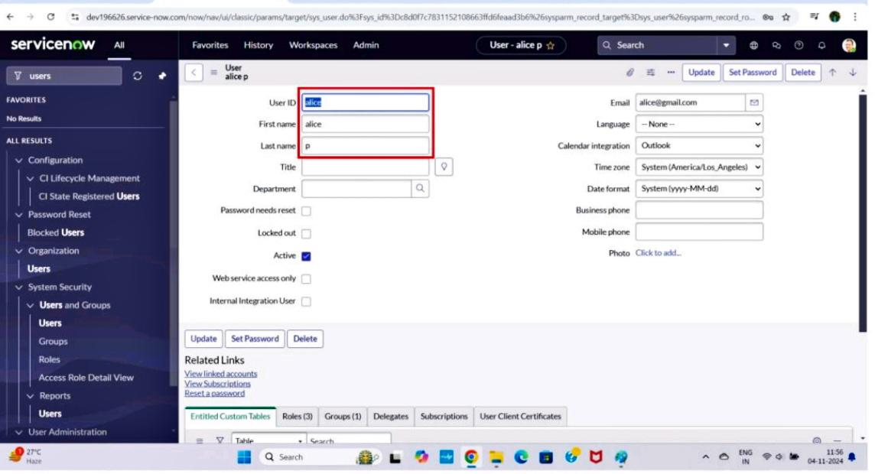Create one more user:

8.Create another user with the following details. 9.Click on submit.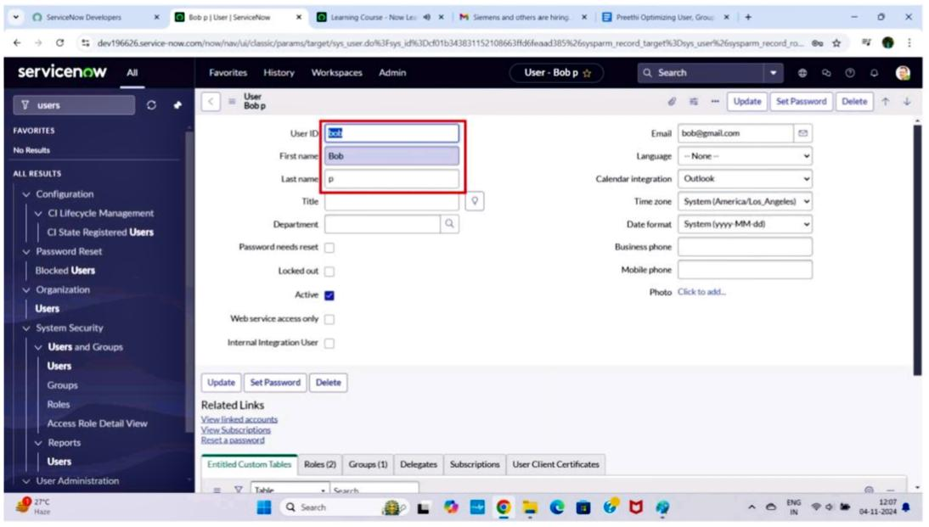

**Milestone 2 : Groups**

**Activity 1: Create Groups**

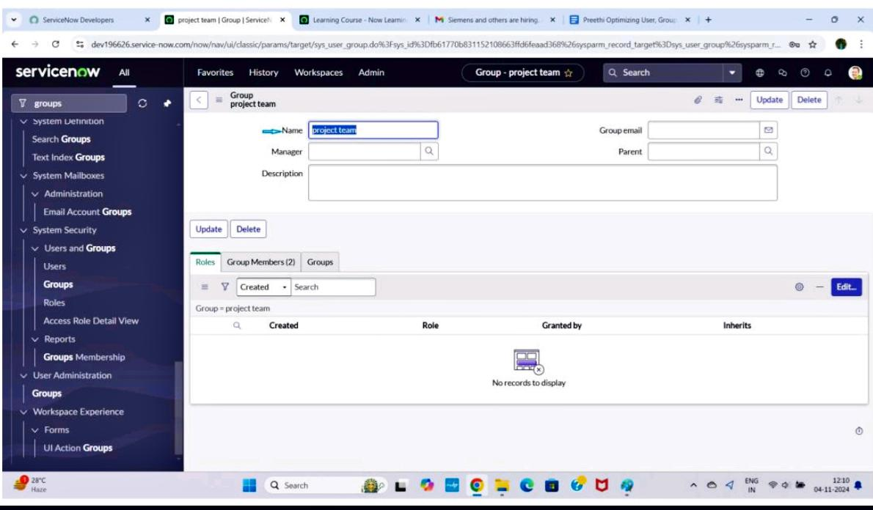**1. Open service now 2. Click on All >> search for groups 3. Select groups under system securities 4. Click on new 5.Fill the following details to create a new group 6. Click on submit**

**Milestone 3 : Roles**

**Activity 1: Create roles**

**1.Open service now. 2. Click on All >> search for roles 3. Select roles under system security. 4. Click on new. 5. Fill the following details to create a new role. 6. Click on submit**

**Create one more role:**

**7.Create another role with the following details**

**8.Click on submit**

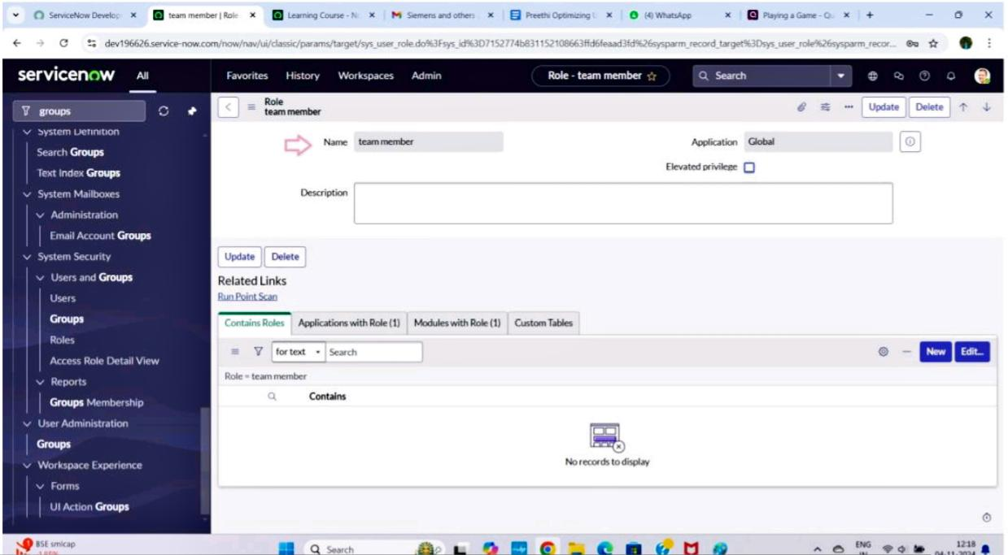**Milestone 4 : Table Activity 1: Create Table**

**1.Open service now. 2. Click on All >> search for table. 3. Select tables under system definition. 4. Click on new. 5. Fill the following details to create a new table. Label : project table. Check the boxes Create module & Create mobile module 6. Under new menu name : project table 7. Under table columns give the columns**

**8.click on submit**

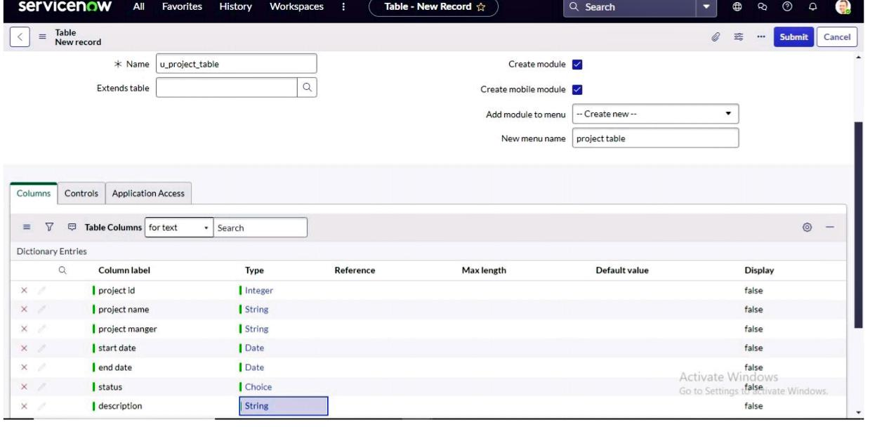**Create one more table:**

**9.Create another table as:task table 2 and fill with following details. 10. Click on submit.**

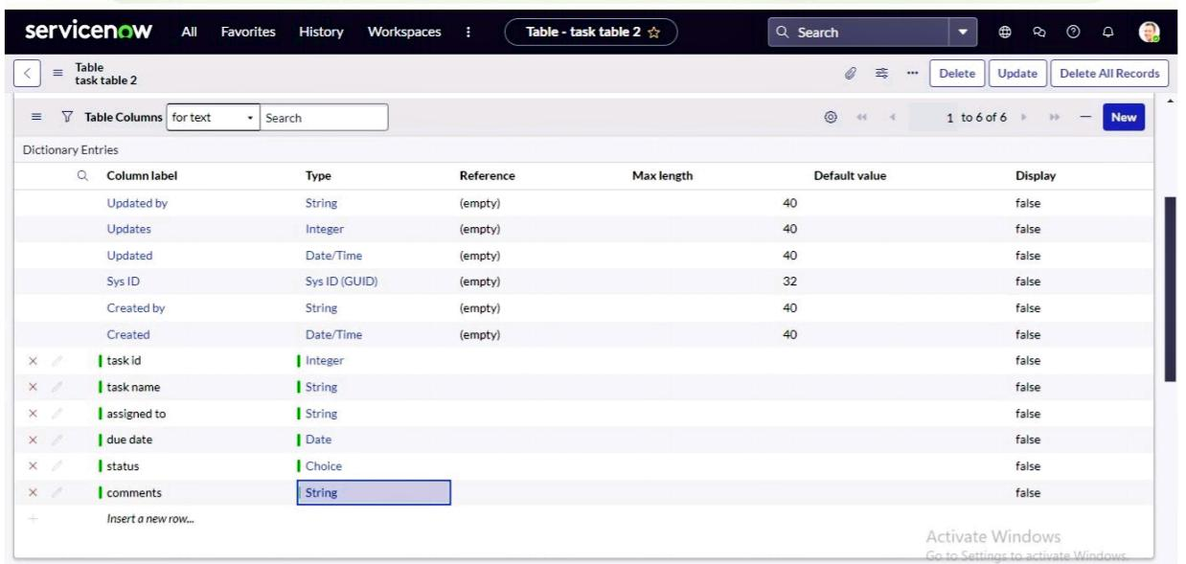

**Milestone 5 : Assign users to groups.**

**Activity 1: Assign users to project team group**

**1.Open service now. 2.Click on All >> search for groups. 3.Select tables under system definition 4.Select the project team group. 5.Under group members 6.Click on edit 7.Select alice p and bob p and save**

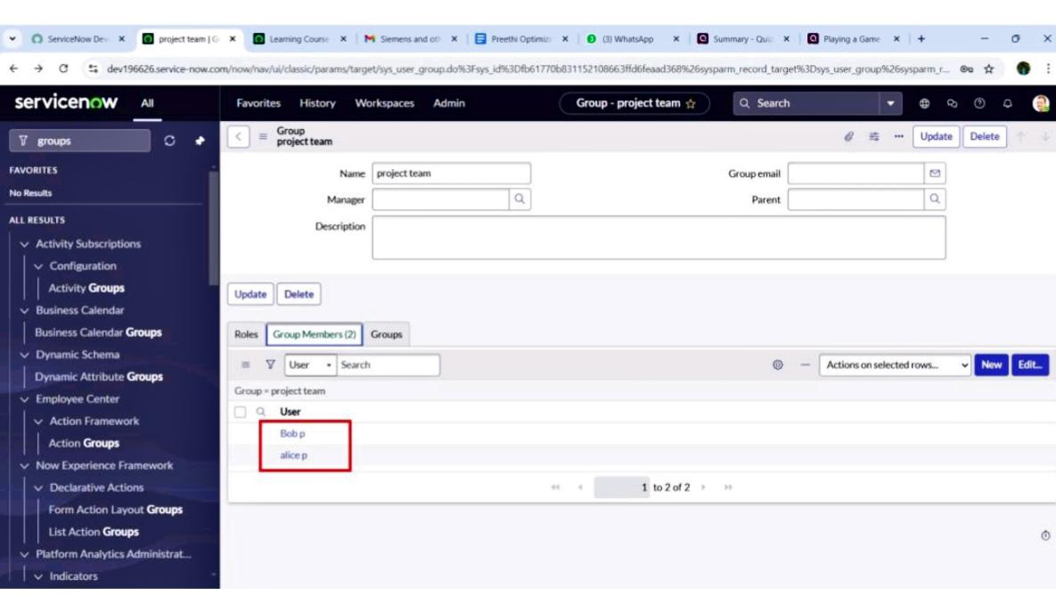**Milestone 6 : Assign roles to users . Activity 1: Assign roles to alice user. 1.Open servicenow.Click on All >> search for user 2.Select tables under system definition 3.Select the project manager user 4.Under project manager. 5.Click on edit 6.Select project member and save 7.click on edit add u_project_table role and u_task_table role 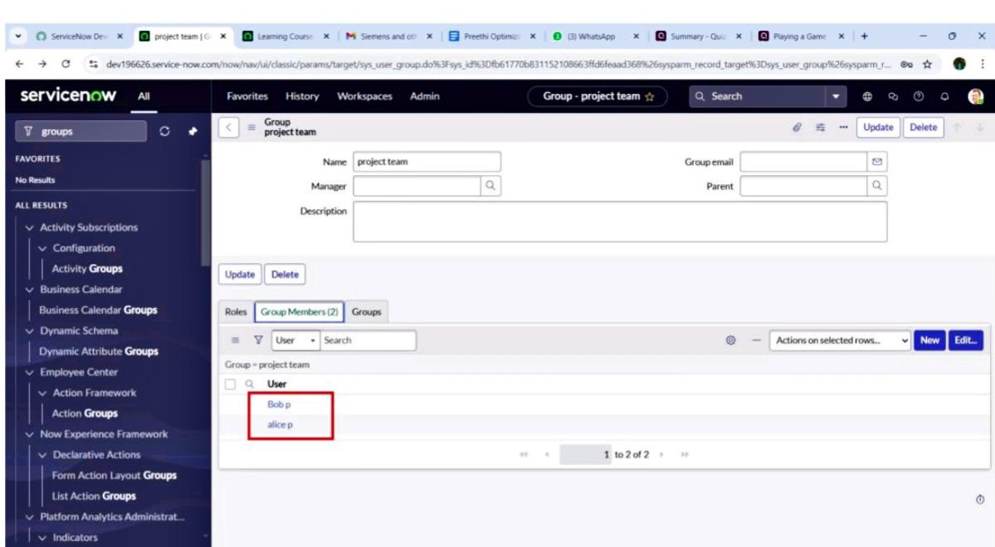8.click on save and update the form.**

**Milestone 7 : Application access**

**Activity 1: Assign table access to application**

**1. While creating a table it automatically create a application and module for that table. 2. Go to application navigator search for search project table application 3. Click on edit module. 4. Give project member roles to that application 5. Search for task table2 and click on edit application. 6. Give the project member and team member role for task table 2 application**

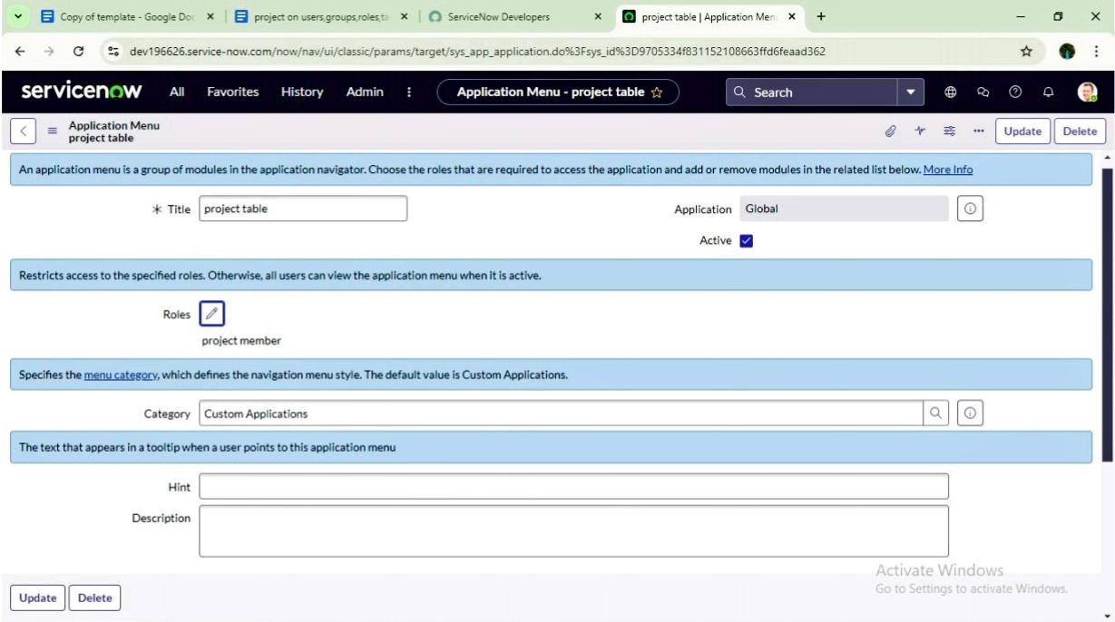

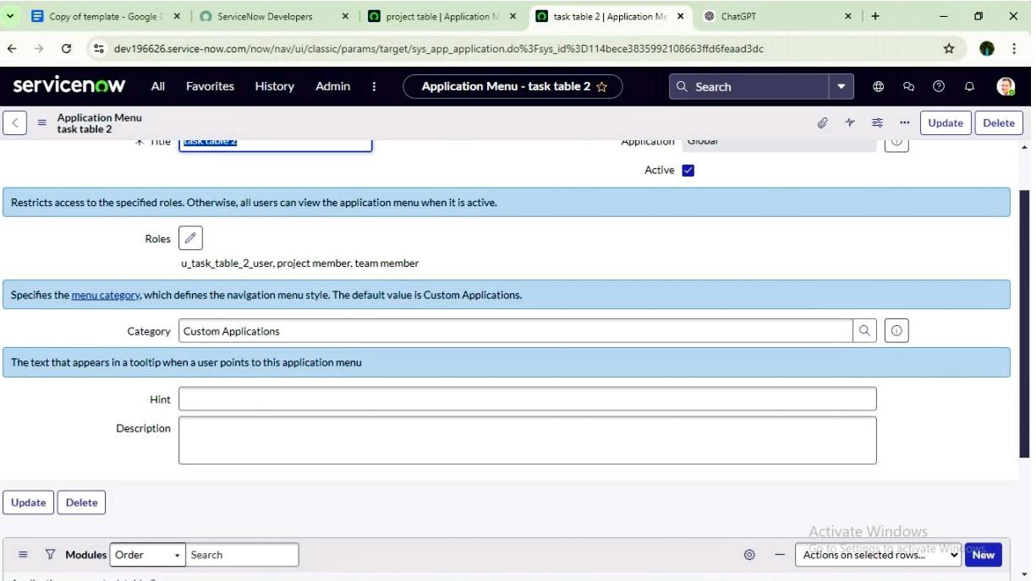

**Milestone 8 :Access control list**

**Activity 1: Create ACL**

**1. Open service now. 2. Click on All >> search for ACL 3. Select Access Control(ACL) under system security. 4. Click on elevate role 5. Click on new**

**6.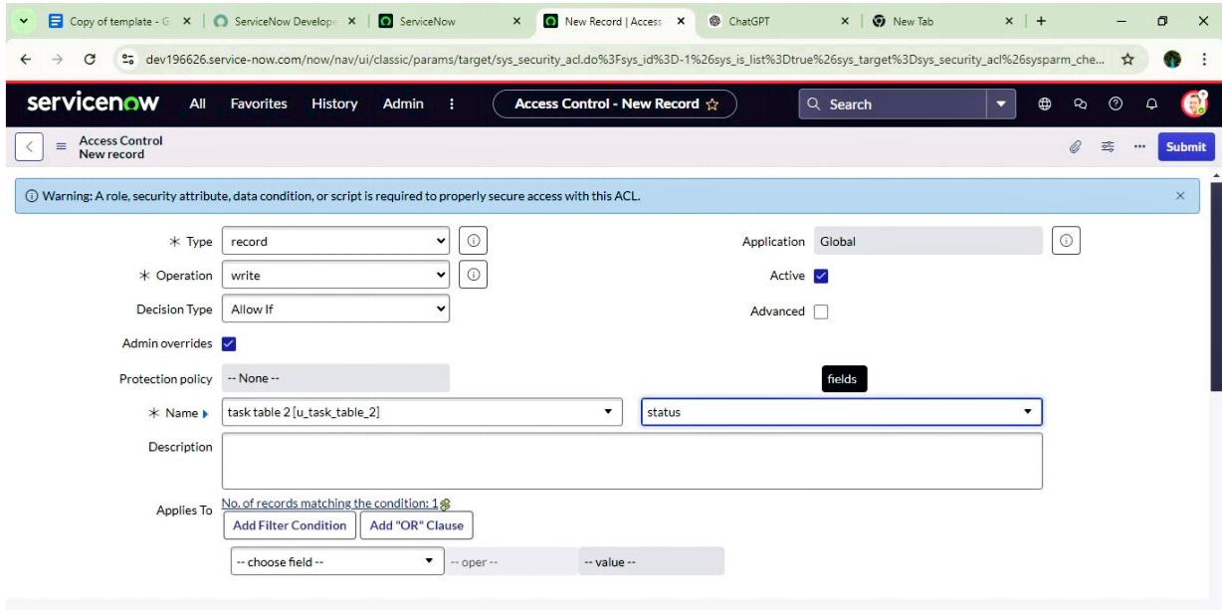Fill the following details to create a new ACL 7. Scroll down under requires role. 8. Double click on insert a new row 9. Give task table and team member role 10. Click on submit 11. Similarly create 4 acl for the following fields. 12.Click on profile on top right side 13.Click on impersonate user 14.Select bob user 15.Go to all and select task table2 in the application menu bar 16. Comment and status fields are have the edit access**

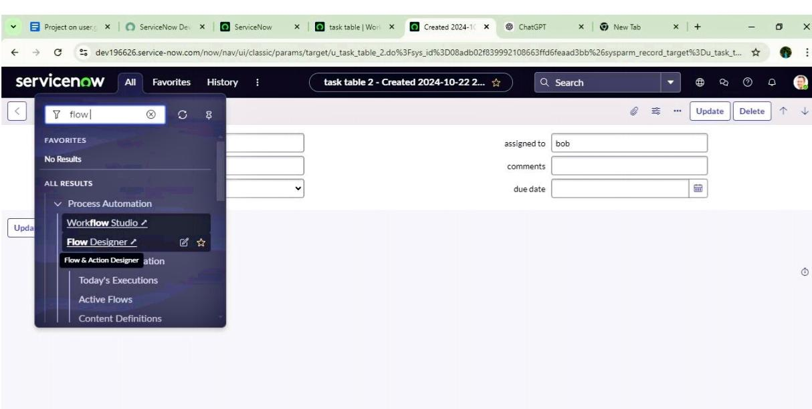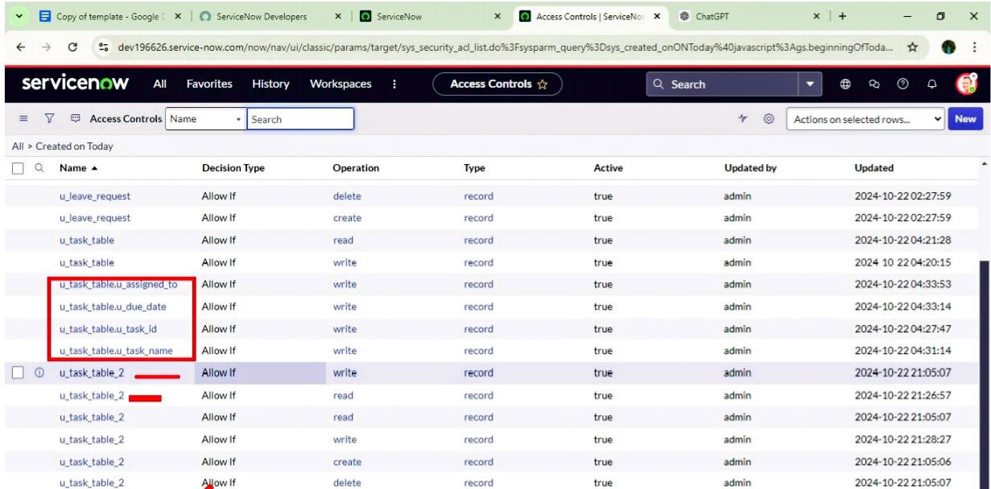**Milestone 9: Flows**

**Activity 1: Create a Flow to Assign operations ticket to group**

1. 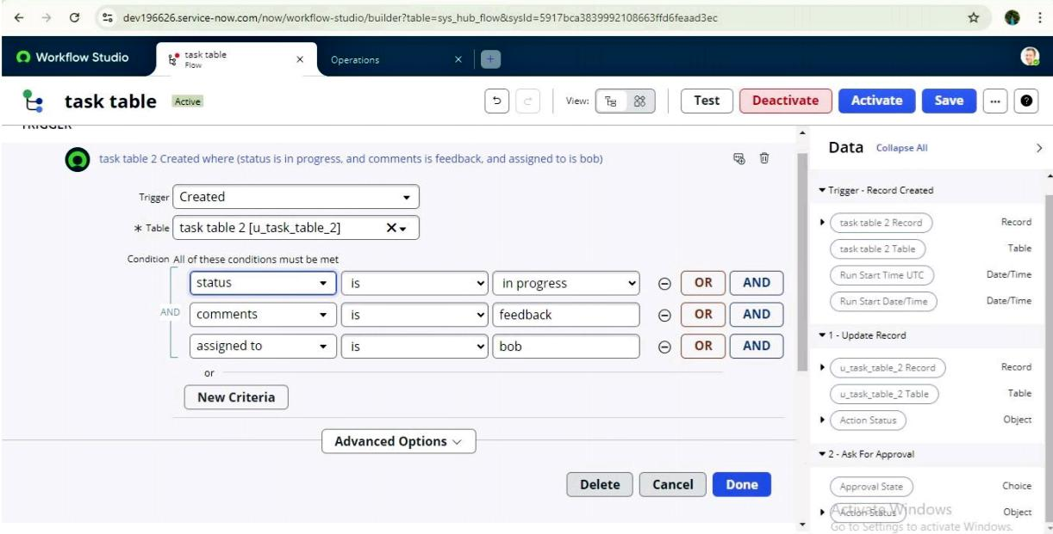**Open service now. 2. Click on All >> search for Flow Designer 3. Click on Flow Designer under Process Automation. 4. After opening Flow Designer Click on new and select Flow. 5. Under Flow properties Give Flow Name as “ task table”. 6. Application should be Global. 7. Click build flow.**

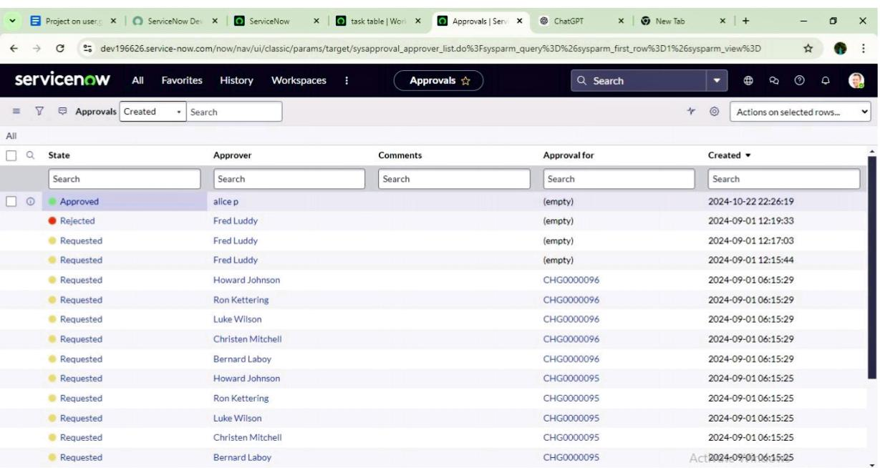

**Conclusion:**

**Optimizing user, group, and role management with access control and workflows enhances both security and efficiency within an organization. By implementing structured role-based access, streamlined approval workflows, and centralized identity governance, organizations can reduce administrative overhead while ensuring that the right users have the right access at the right time. This not only minimizes risks of unauthorized access but also improves compliance with regulatory requirements. Ultimately, an optimized system fosters scalability, adaptability, and seamless collaboration—supporting business growth while maintaining robust security controls**